  
Starcraft

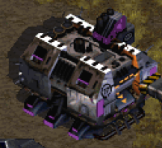

|  |  |
| --- | --- |
| ***barracks*** |  |
| **Attributen** | **Functies** |
|  | Allies_spawnen(X_cor, Y_cor) |
| Levens | Opstijgen(X_cor, Y_cor) |
| beweegbaarheid | Vernietigd worden(Levens) |

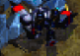

|  |  |
| --- | --- |
| ***Miner drones*** |  |
| **Attributen** | **Functies** |
| Snelheid | Lopen(X_cor, Y_cor, speed) |
| Mijn-snelheid | Doodgaan() |
| levens | Mijnen() |

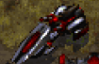

|  |  |
| --- | --- |
| ***zealot*** |  |
| **Attributen** | **functies** |
| Snelheid | Doodgaan(Levens) |
| Levens | Bewegen(speed, X_cor, Y_cor) |
| Damage | Schieten(X_cor, Y_cor) |



Super street fighter

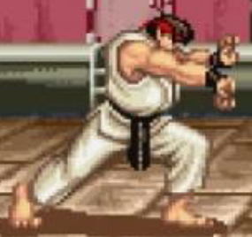

|  |  |
| --- | --- |
| ***Ryu*** |  |
| **Attributen** | **functies** |
| Levens | Lopen(speed, X_cor, Y_cor) |
| Snelheid | Doodgaan(Levens) |
| Score | Aanvallen() |



|  |  |
| --- | --- |
| ***vuurbal*** |  |
| **Attributen** | **Functies** |
| snelheid | Bewegen(speed, X_cor, Y_cor) |
| damage | Verdwijnen() |

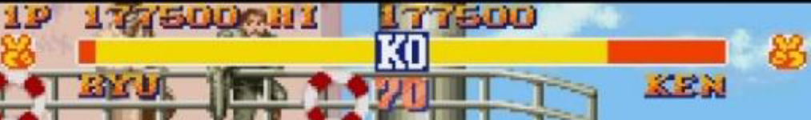

|  |  |
| --- | --- |
| ***levensbalk*** |  |
| **Attributen** | **Functies** |
| volheid | Vullen(Fullness) |
| score | Leeggaan(Fullness) |

  
shovel knight

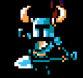

|  |  |
| --- | --- |
| ***Shovel knight*** |  |
| **Attributen** | **functies** |
| Levens | Lopen(speed, X_cor, Y_cor) |
| Snelheid | Aanvallen() |
|  | Springen(X_cor, Y_cor, jump_height) |



|  |  |
| --- | --- |
| ***UI*** |  |
| **Attributen** | **Functies** |
| #potions | #Levens veranderen(Levens) |
| #levens | #potions veranderen(potions) |

|  |  |
| --- | --- |
| ***Boss*** |  |
| **Attributen** | **Functies** |
| Levens | Doodgaan() |
| Damage | Aanvallen() |
|  | Speciale aanval() |

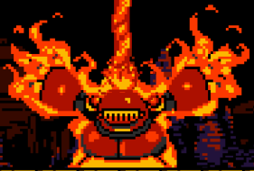

  
league of legends

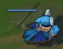

|  |  |
| --- | --- |
| ***minion*** |  |
| **Attributen** | **Functies** |
| Levens | Doodgaan() |
| Damage | Aanvallen() |
| Snelheid | Lopen(speed, X_cor, Y_cor) |

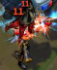

|  |  |
| --- | --- |
| ***hero*** |  |
| **Attributen** | **Functies** |
| Levens | Doodgaan() |
| Damage | Aanvallen() |
| Snelheid | Lopen(speed, X_cor, Y_cor) |

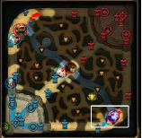

|  |  |
| --- | --- |
| ***map*** |  |
| **Attributen** | **Functies** |
| #vijanden | Show_enemies(number_enemies) |
| #turrets | Aantal turrets laten zien(number_turrets) |

  
final fantasy Vlll

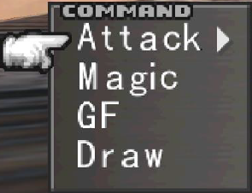

|  |  |
| --- | --- |
| ***Command*** |  |
| **Attributen** | **Functies** |
| #options | Select(current_position) |
| Selecteer baar | Ga omhoog(current_position) |
|  | Ga omlaag(current_position) |

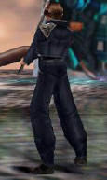

|  |  |
| --- | --- |
| ***Zell*** |  |
| **Attributen** | **Functies** |
| Levens | Doodgaan() |
| Damage | Aanvallen() |
|  | Special(special) |

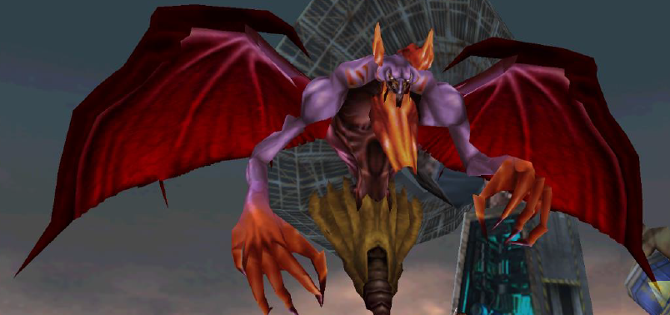

|  |  |
| --- | --- |
| ***Vijand*** |  |
| **Attributen** | **Functies** |
| Levens | Doodgaan() |
| Damage | Aanvallen() |
| Verdediging | Special(special) |

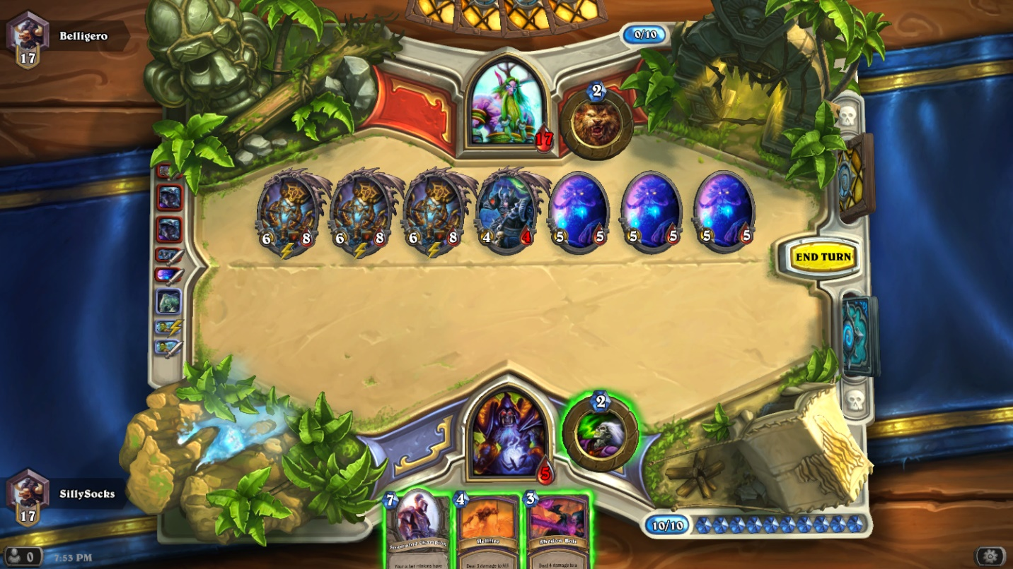

Hearthstone

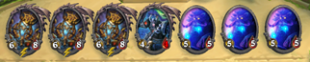

|  |  |
| --- | --- |
| **Minions** |  |
| **Attributen** | **Functies** |
| Aanval | Aanvallen() |
| Levens | Doodgaan() |
| Ability | Effect() |

|  |  |
| --- | --- |
| **Hand** |  |
| **Attributen** | **Functies** |
| Hold | Handgrootte() |
| Select | Usemana() |
| Target | Playcard() |
| Play |  |

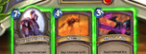



­­­­

|  |  |
| --- | --- |
| **Hero** |  |
| **Attributen** | **Functies** |
| Aanval | Aanvallen() |
| Levens | Doodgaan() |
| Heropower | Heropower() |
| Armor | Armorgain() |
| Heal | Healthgain() |